

Lab Report

Course Code: CSE 314

Course Name: Computer Networks Lab

Experiment No: 02

Experiment name : Configuring multiple static router connection

Date of submission : 13-08-2023

Submitted To : Submitted By:

Narayan Ranjan Chakraborty Name: Rayhan Rafin

Associate Head and Associate Professor ID: 213-15-4278

Department of CSE Section: 60_B

Daffodil International University

Title**:** Configuring multiple static router connection

Equipment:

End device – 3 pc

Connecting device – 3 (3 router)

Connection type – copper cross (router to pc),

serial DCE (router to router)

Topology:

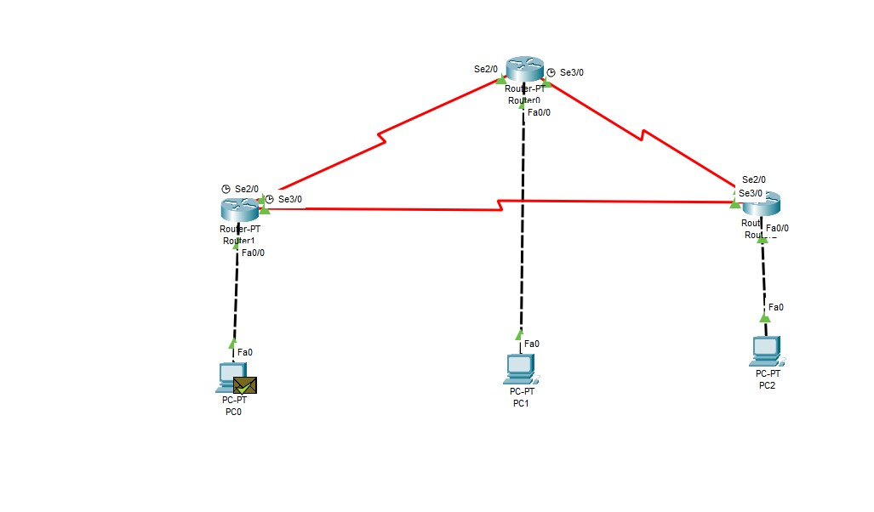

Configuration:

PC –

|  |  |  |  |
| --- | --- | --- | --- |
| PC | IP | Subnet Mask | Gateway |
| 0 | 200.200.200.130 | 255.255.255.128 | 200.200.200.129 |
| 1 | 201.201.201.194 | 255.255.255.192 | 201.201.201.193 |
| 2 | 150.150.148.2 | 255.255.252.0 | 150.150.148.1 |

Right –

|  |  |  |  |
| --- | --- | --- | --- |
| Router | Port | IP | Subnet |
| 1 | S2/0 | 10.0.0.1 | 255.192.0.0 |
| S3/0 | 12.0.0.1 | 255.240.0.0 |
| 0 | S2/0 | 10.0.0.2 | 255.192.0.0 |
| S3/0 | 11.0.0.1 | 255.224.0.0 |
| 2 | S2/0 | 12.0.0.2 | 255.240.0.0 |
| S3/0 | 11.0.0.2 | 255.224.0.0 |

Command Line Interface (router):

**IP Adding:**

**Router -01:**

Router>en

Router#config t

Router(config)#int f0/0

Router(config-if)#ip add 200.200.200.129 255.255.255.128

Router(config-if)#no shut

Router(config-if)#

Router(config-if)#exit

Router(config)#int s2/0

Router(config-if)#ip add 10.0.0.1 255.192.0.0

Router(config-if)#no shut

Router(config-if)#clock rate 64000

Router(config-if)#exit

Router(config)#int s3/0

Router(config-if)#ip add 12.0.0.1 255.240.0.0

Router(config-if)#no shut

Router(config-if)#clock rate 64000

Router(config-if)#exit

Router(config)#exit

Router#

Router#copy run start

Destination filename [startup-config]?

Building configuration...

[OK]

Router#

**Router-02:**

Router>en

Router#config t

Router(config)#int s2/0

Router(config-if)#ip add 10.0.0.2 255.192.0.0

Router(config-if)#no shut

Router(config-if)#

Router(config-if)#exit

Router(config)#int f0/0

Router(config-if)#ip add 201.201.201.193 255.255.255.192

Router(config-if)#no shut

Router(config-if)#exit

Router(config)#int s3/0

Router(config-if)#ip add 11.0.0.1 255.224.0.0

Router(config-if)#no shut

Router(config-if)#clock rate 64000

Router(config-if)#exit

Router(config)#exit

Router#

Router#copy run start

Destination filename [startup-config]?

Building configuration...

[OK]

Router#

Router#

**Router-03:**

Router>en

Router#config t

Router(config)#int f0/0

Router(config-if)#ip add 150.150.148.1 255.255.252.0

Router(config-if)#no shut

Router(config-if)#

Router(config-if)#exit

Router(config)#int s2/0

Router(config-if)#ip add 11.0.0.2 255.224.0.0

Router(config-if)#no shut

Router(config-if)#

Router(config-if)#exit

Router(config)#int

Router(config)#int s3/0

Router(config-if)#ip add 12.0.0.2 255.240.0.0

Router(config-if)#no shut

Router(config-if)#

Router(config-if)#exit

Router(config)#exit

Router#

Router#copy run start

Destination filename [startup-config]?

Building configuration...

[OK]

Router#

**Routing**

**Router -01:**

Router>en

Router#config t

Router(config)#ip route 200.200.200.128 255.255.255.128 10.0.0.2

Router(config)#ip route 150.150.148.0 255.255.252.0 12.0.0.2

Router(config)#exit

Router#

Router#copy run start

Destination filename [startup-config]?

Building configuration...

[OK]

Router#

**Router-02:**

Router>en

Router#config t

Router(config)#ip route 200.200.200.128 255.255.255.128 10.0.0.1

Router(config)#ip route 150.150.148.0 255.255.252.0 11.0.0.2

Router(config)#exit

Router#

Router#copy run start

Destination filename [startup-config]?

Building configuration...

[OK]

Router#

**Router-03:**

Router>en

Router#config t

Router(config)#ip route 200.200.200.128 255.255.255.128 12.0.0.1

Router(config)#ip route 201.201.201.192 255.255.255.192 11.0.0.1

Router(config)#exit

Router#

Router#copy run start

Destination filename [startup-config]?

Building configuration...

[OK]

Router#

Result:

**Pc0 to Pc2:**

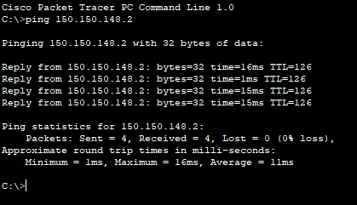

**PC2 to PC1:**

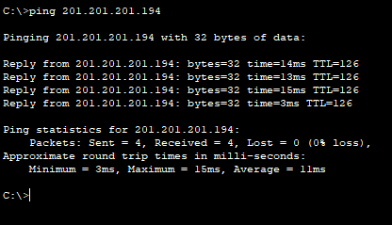

**Comment:**

1. In this Lab we learned how to configure a router to pc
2. We also learned how to configure between two routers
3. We also learned how to configure static routing path

This experiment will help us understanding how static routing works and how to optimize it